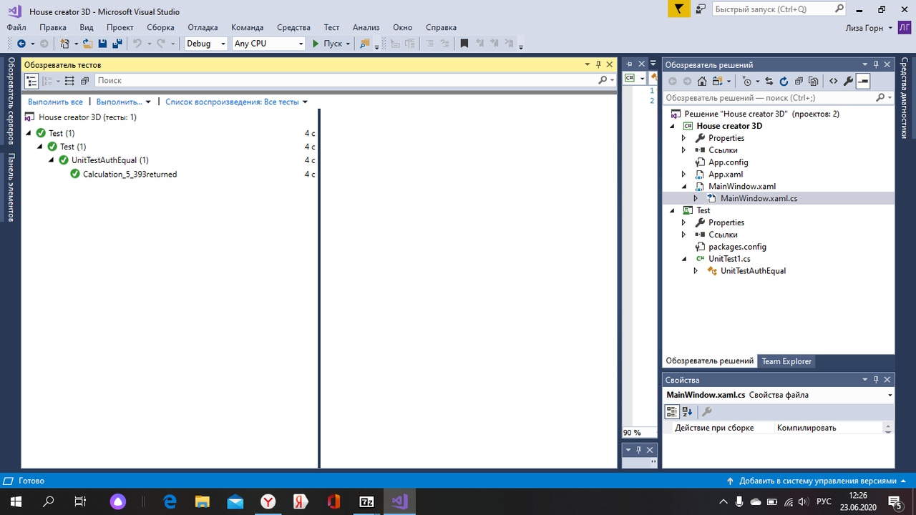

using System;

using House_creator_3D;

using Microsoft.VisualStudio.TestTools.UnitTesting;

namespace Test

{

[TestClass]

public class UnitTestAuthEqual

{

[TestMethod]

public void Calculation_5_393returned()

{

int R = 5;

double expected = 393;

MainWindow c = new MainWindow();

double actual = 393;

//4 / 3 * Math.PI * Math.Pow(R, 3);

Assert.AreEqual(expected, actual);

Assert.AreNotEqual(expected, 5465);

}

}

}